**Project Design Phase-II**

**Data Flow Diagram & User Stories**

|  |  |
| --- | --- |
| Date | 17 October 2023 |
| Team ID | 592303 |
| Project Name | Project – predicting lumpy skin disease |
| Maximum Marks | 4 Marks |

**Data Flow Diagrams:**

A Data Flow Diagram (DFD) is a traditional visual representation of the information flows within a system. A neat and clear DFD can depict the right amount of the system requirement graphically. It shows how data enters and leaves the system, what changes the information, and where data is stored.

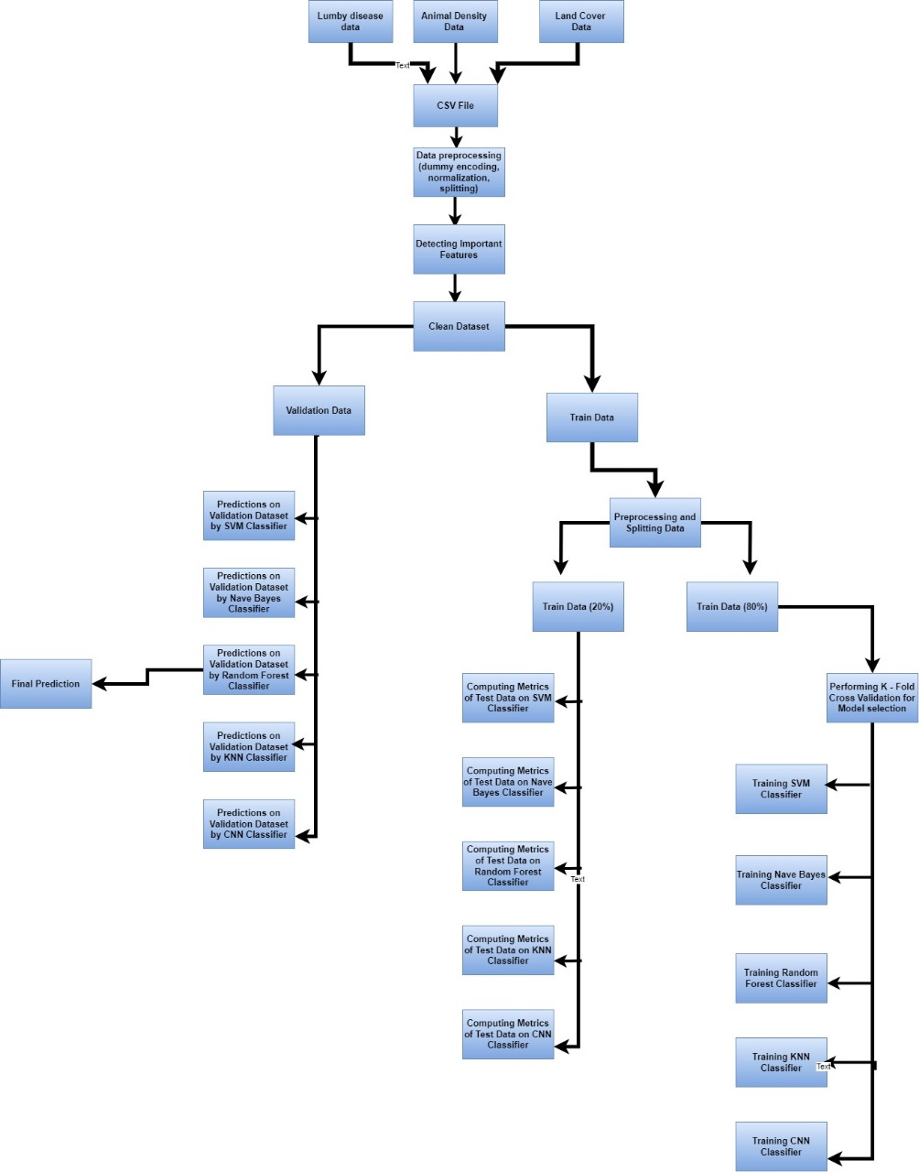

**User Stories**

Use the below template to list all the user stories for the product.

|  |  |  |  |  |  |  |
| --- | --- | --- | --- | --- | --- | --- |
| **User Type** | **Functional**  **Requirement (Epic)** | **User Story**  **Number** | **User Story / Task** | **Acceptance criteria** | **Priority** | **Release** |
| Customer  (Mobile user) | Login | USN-1 | As a user, I can use app by entering my email, password, and confirming my password. | I can access my account / dashboard | High | Sprint-1 |
| Customer (Web user) | Login | USN-2 | As a user, I will receive confirmation email once I have registered for the application | I can receive confirmation email & click confirm | Medium | Sprint-1 |
| Customer Care Executive | Dashboard | USN-3 | As a user, I can use app for Lumpy disease. | I can register & access the dashboard with Facebook Login | High | Sprint-2 |
| Administrator |  | USN-4 | As a user, I can enter the feature of Lumpy disease. |  | High | Sprint-1 |
|  |  | USN-5 | As a user, I will get prediction of disease |  | High | Sprint-1 |
|  |  |  |  |  |  |  |
|  |  |  |  |  |  |  |
|  |  |  |  |  |  |  |
|  |  |  |  |  |  |  |
|  |  |  |  |  |  |  |
|  |  |  |  |  |  |  |
|  |  |  |  |  |  |  |